Subject Matter: Geography
Lesson Title: Characteristics of Culture
Lesson Outcome: Recognize and classify characteristics of culture
Standards: WGS 2.3, 3.1, 3.3, 3.4, 3.7 / NS 1, 4, 5, 9, 10, 12, 17

Characteristics of Culture
Understanding the characteristics of culture can help us better understand how cultures develop and function. Reach each of the characteristics of culture below to learn more about his topic.
Learned
A person is not born with culture; culture is learned. Language is a good example of this concept. A child may be born in one culture but then adopted into and raised in another.
Does the child naturally speak the language of their biological parents? No, they learn the language of the culture in which they are raised. This also includes the dialect and accent of that language.
Transmitted
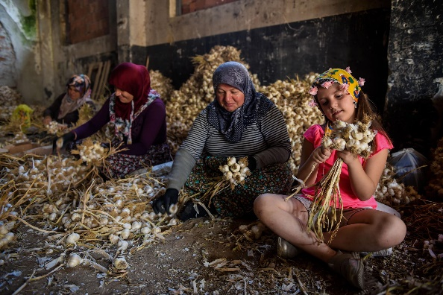
Culture is transmitted. This means that culture is passed from one generation to the next. Do you have a family recipe? Grandma’s chicken noodle soup, or Aunt Melba’s chocolate brownies?
This is an important aspect of culture because there are characteristics of culture that will die if they are not transmitted from one generation to the next.

Image by Hamza Sefa Yilmaz

Symbolic
Culture is based on symbols. These can be images or icons that represent a culture and what members of that culture believe. A flag is a good, visible example. The colors and pictures on a flag symbolize things that are important to a culture. Currency can also be a good place to look since money usually has symbols that represent cultural characteristics of a group of people. These are examples of the symbols of a nation; however, cultures are often much smaller than a nation, and so cultural symbols are not always as visible and recognizable as the examples given here.

Changeable and Adaptive
Culture is changeable and adaptive. This is easily seen with what is known as the generation gap. When you consider the culture of your parents or grandparents, do you see differences between their culture and your own? The music you listen to, the clothes you wear, the media you consume, the technology you use. When you compare these customs to the customs of an older generation, you can see that such factors change over time. Culture does change. This does not mean that you don’t belong to the same culture as your family; it simply means that some cultural traits change over time. Culture adapts so it can survive.
Integrated
Culture is integrated. This means that one aspect of a person’s culture often influences another aspect. The best example of this idea is religion. A person’s religion often informs what a person eats, wears, listens to, or speaks and may dictate their values. If a person’s religion changes, these other cultural traits often change as well since they are all integrated.
Sample Computer Graded Assessment
Choose the option that represents how culture is symbolic.
- a country flag*
- a quinceañera celebration
- Spanish or French
- Grandma’s chicken soup
Choose the example that shows that culture is integrated.
- Followers of Hinduism are usually vegetarian, and those that eat meat do not eat beef.*
- A young woman wears a pink dress for her quinceañera instead of a white dress.
- A classmate proudly wears his country flag on his t-shirt during a soccer match.
- A grandmother teaches her granddaughter to make chicken confit, a traditional French dish.

Sample Teacher Graded Prompt
In this lesson, you learned that religion is an example of how culture is integrated; one aspect of culture can influence other aspects. Choose a world religion—not your own religion—and research how the basic principles of that religion affect the daily lives of the followers of that religion. List 5 examples.
Choose how you want to submit your assignment. Choose 1 of the following:
- An electronic poster that shows the 5 examples with images and explanation for each example. (You can do it in a google slideshow, word document, etc.)
- A video presentation where you explain 5 examples with images.

